**EXPERIMENT 7**

**DQL COMMANDS (COLLEGE SCHEMA)**

**Aim:**

* Display student id and marks from the student table.
* Display faculty id and name from the faculty table.
* Display who got grade A.
* Display whose marks are less than 50.
* Display the female students whose marks are between 50 to 60.
* Delete the failed students.
* Display activity id and name using object.
* Display student id, faculty id using course name condition with object.
* Select department name starting from ‘c’ and faculty name ending with ‘ ’.
* Select activity having characters between ‘ck’.
* Group by faculty id and display.
* Display the students list whose grade is A using having.
* Display the faculty list who are teaching PPS.
* Apply aggregate functions in student marks - max, min, sum, count, avg.

**Components:**

* Instance: It is a collection of information stored in a database at a particular moment.
* Entity: Object that is relevant to the given system. It is represents as a rectangle.
* Attribute: Trait of an entity , relationship or other attribute .It is represented by oval.
* Primary Key: A primary key is a set of column or a set of columns in a whose uniquely identify row in a table.

**Schema:**

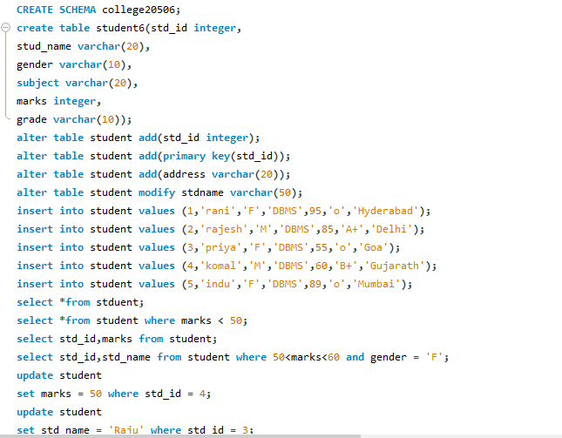 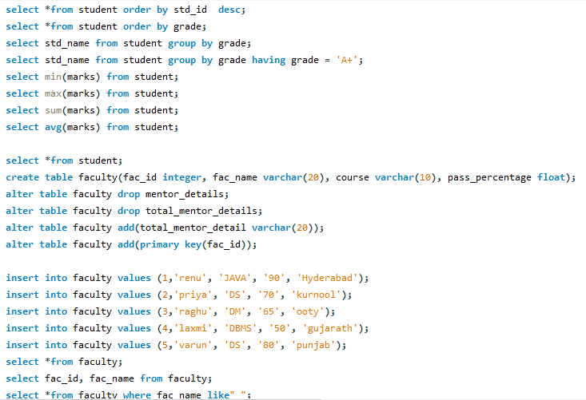 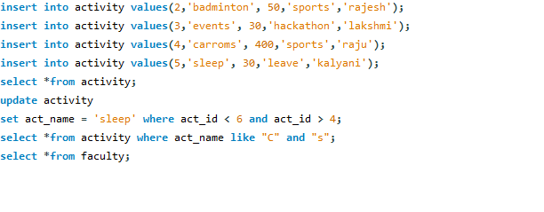**Output:**

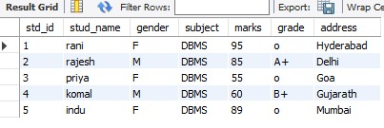

000 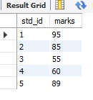

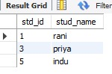

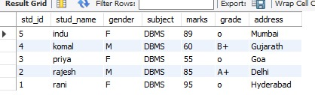

C:\Users\hi\Downloads\WhatsApp Image 2021-07-10 at 8.43.41 PM.jpeg

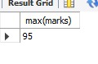

C:\Users\hi\Downloads\WhatsApp Image 2021-07-10 at 8.44.43 PM.jpeg

